How to run PHP application and create a data base

Firstly install XAMPP in your PC/ Laptop then once it is done installing start the following modules below

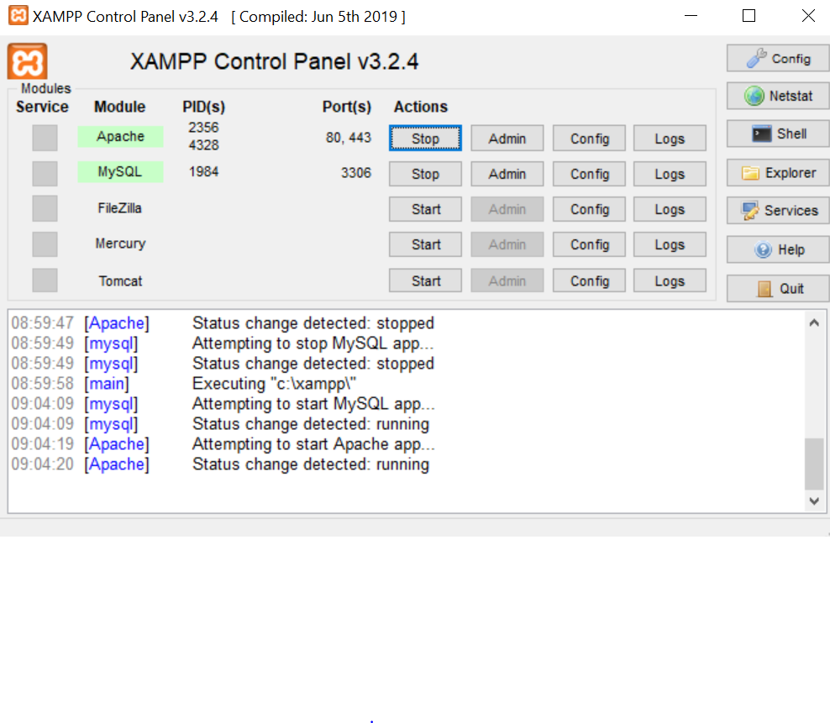

**3.0 RUN YOUR FIRST PHP SCRIPT**

The following is an example about how to run a PHP script. What this program does is show a "Hello World!" text on the screen or webpage.

**3.1 Go to XAMPP server directory**

I'm using Windows, so copy the .php from the Employee-Management-system project and then past them at server directory is "C:\xampp\htdocs\".

**3.2 Open New Tab**

Run it by opening a new tab in your browser

**3.3 Load hello.php**

On you browser window, type http://localhost/login.php

**3.6 Output**

You should see the following output.

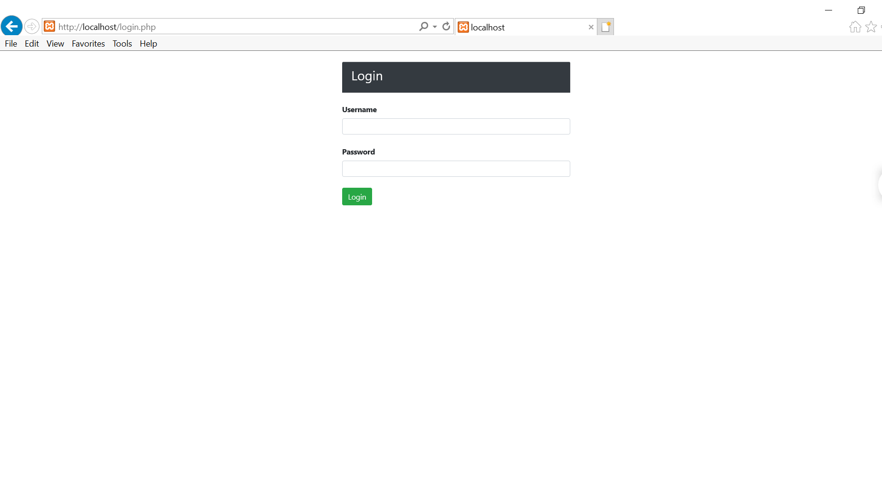

After loging in as an **Admin**

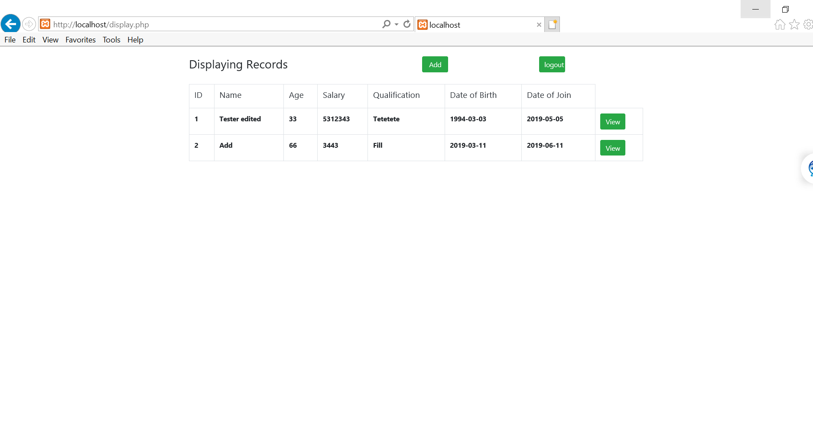

Clicking add button

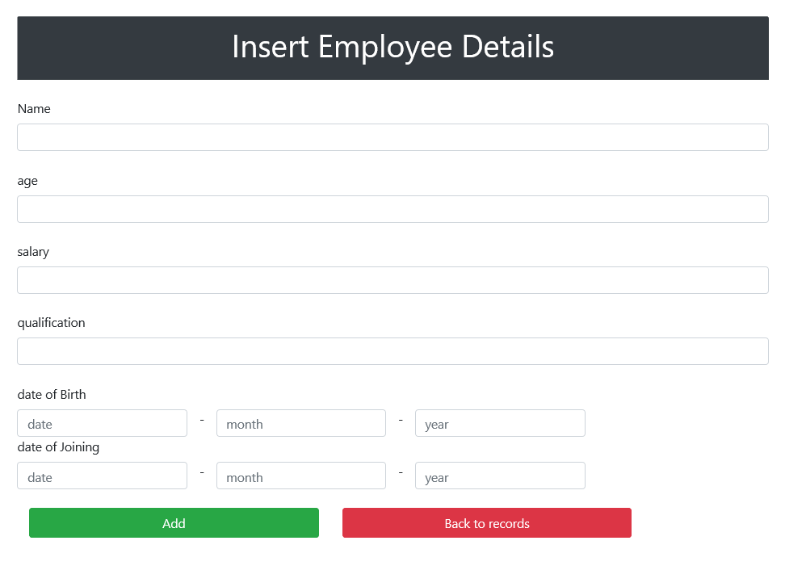

Clicking view button

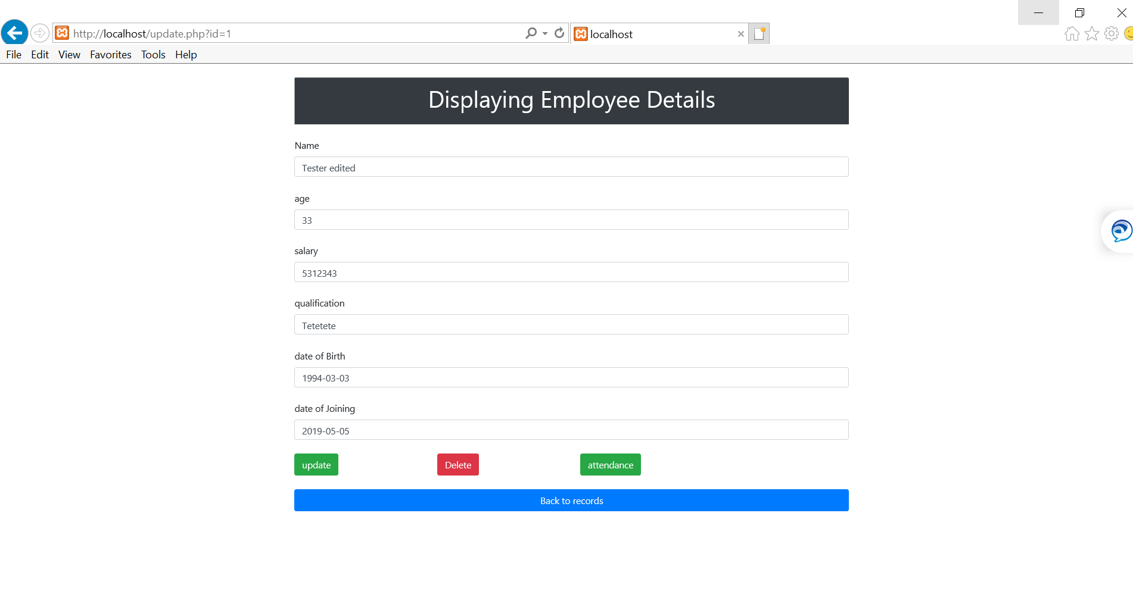

Clicking attendance button

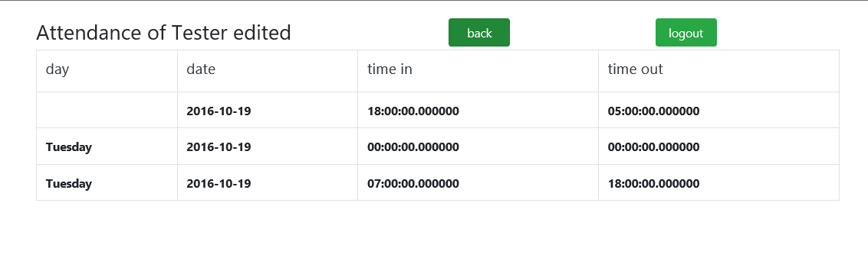

* Delete and update button will execute sql comands

Loggin in as a User/employee

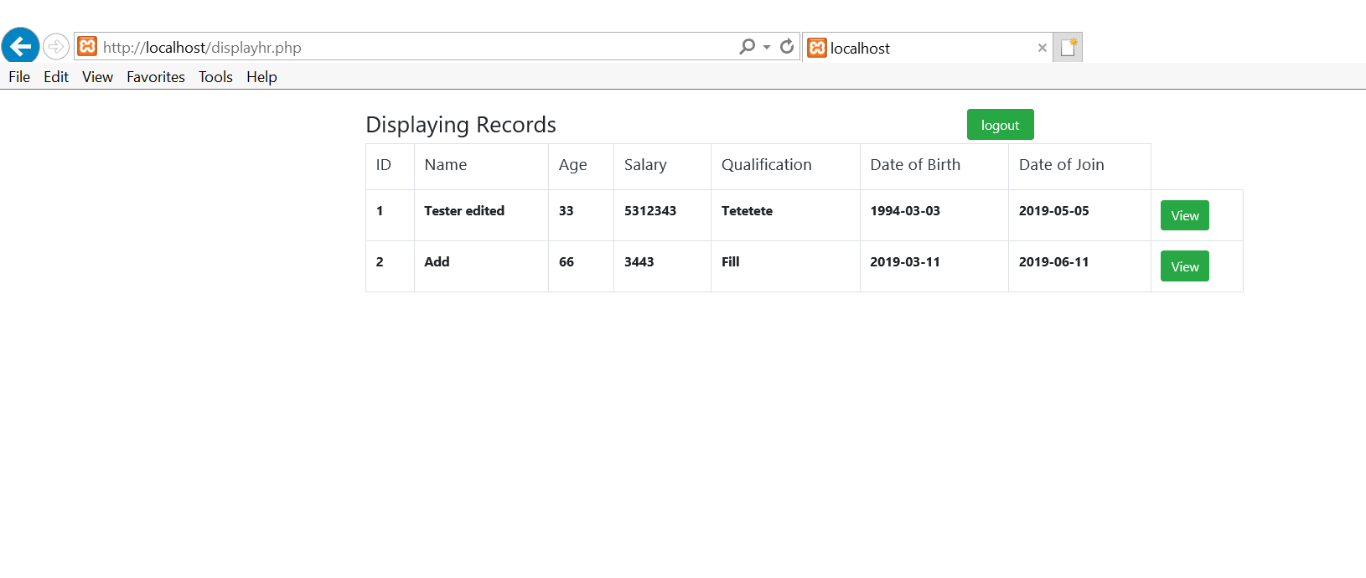

Clicking view button

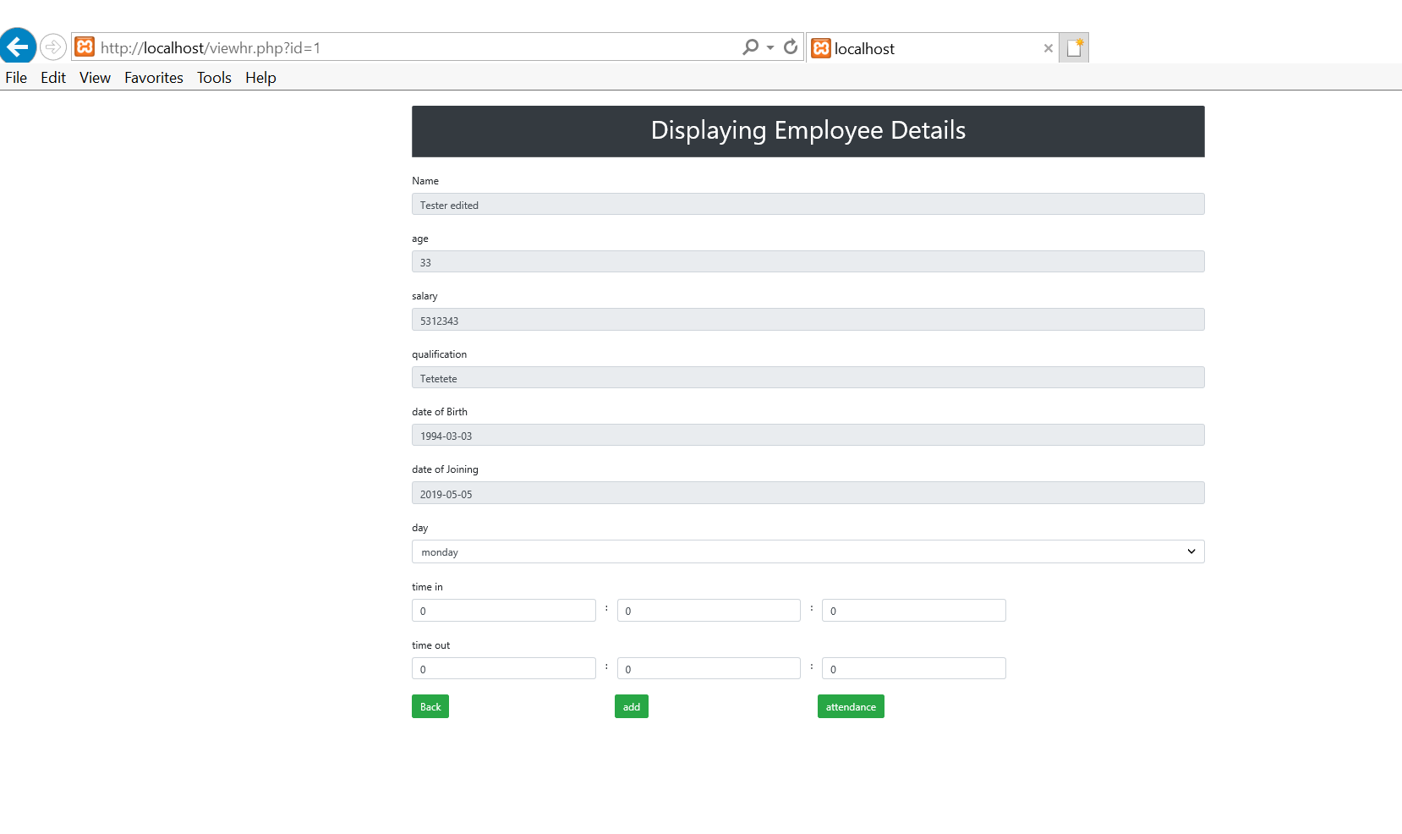

## 4.0 MANAGE MYSQL WITH PHPMYADMIN

[MySQL](https://www.mysql.com/) is an open-source [relational database management system](https://en.wikipedia.org/wiki/Relational_database_management_system) (RDBMS). MySQL is a popular choice of [database](https://en.wikipedia.org/wiki/Database) for use in web applications.

[phpMyAdmin](https://www.phpmyadmin.net/) is a free and open source tool written in PHP intended to handle the administration of MySQL with the use of a web browser. In the following examples, we will see how easy we can handle MySQL with PhpMyAdmin.

### 4.1 Import Database

1. Go to [**http://localhost/phpmyadmin/**](http://localhost/phpmyadmin/)
2. Under *Databases*, open phpMyAdmin by clicking the **phpMyAdmin** icon
3. On the left, select the database that you will be working with
4. Click **Import** in the top menu
5. Under **File to Import**, click **Browse** and select the backup file you previously created (it will either be a .sql .zip or .tar.gz file)
6. Click **Go** at the bottom right to import the database file
7. When the database has been imported successfully, you should see a message at the top of the page similar to: *Import has been successfully finished, ## queries executed*

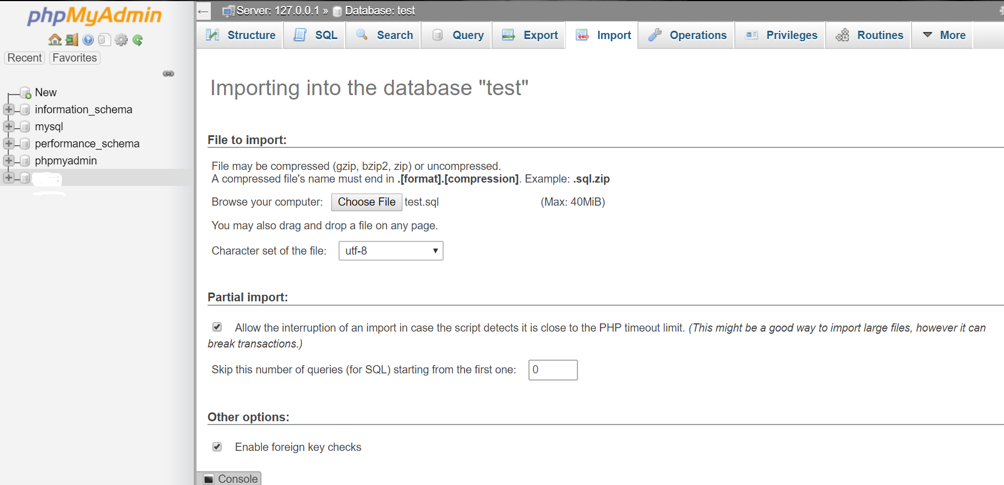

The following Tables will be added

employee

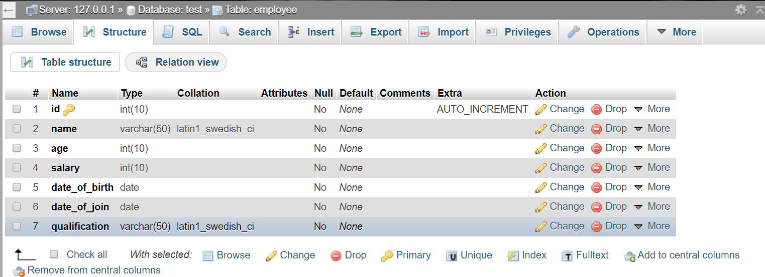

login

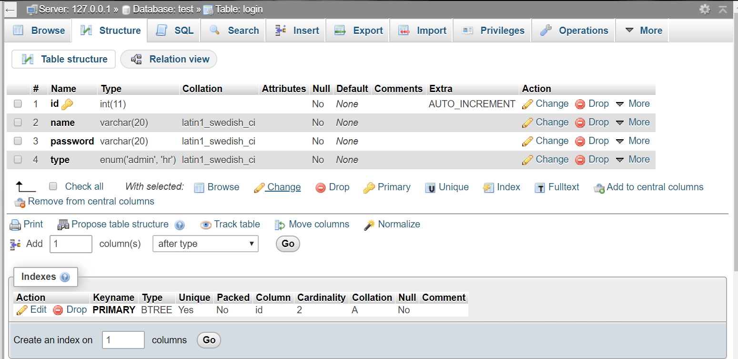

time

